**DATA ANALYTICS ASSIGNMENT – 3**

Allamudi.Yamini

4th B.Tech (CSE)

VNITSW

20NN1A0562

**Running Total:**

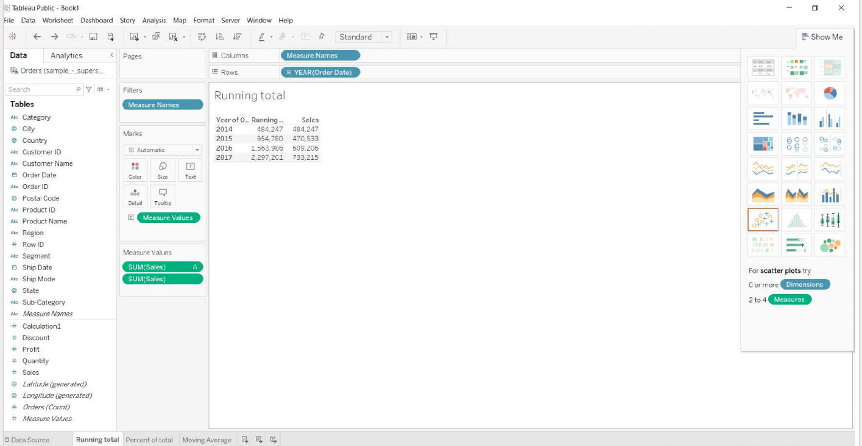

**Percent of Total:**

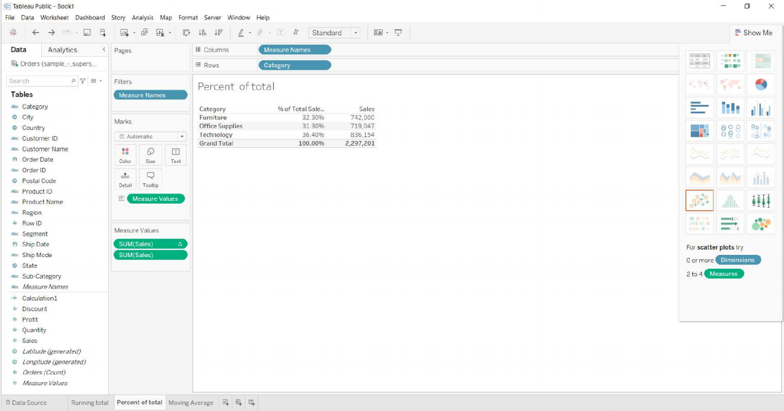

**Moving Average:**

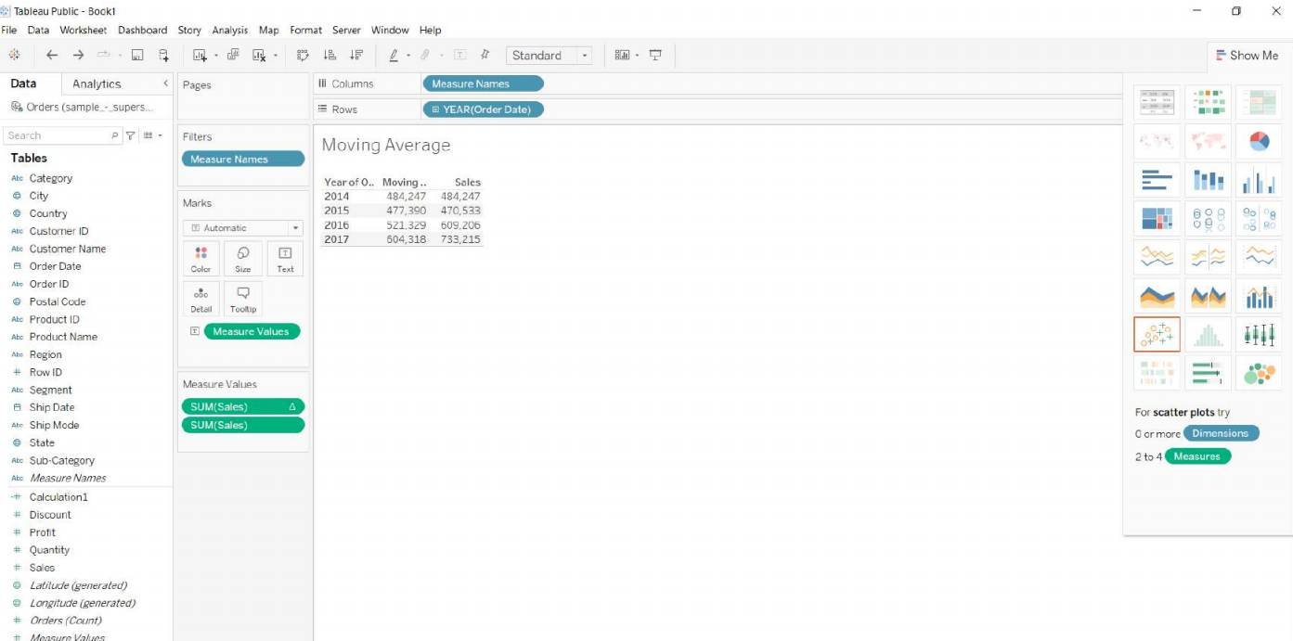

**Calculation Field -1:**

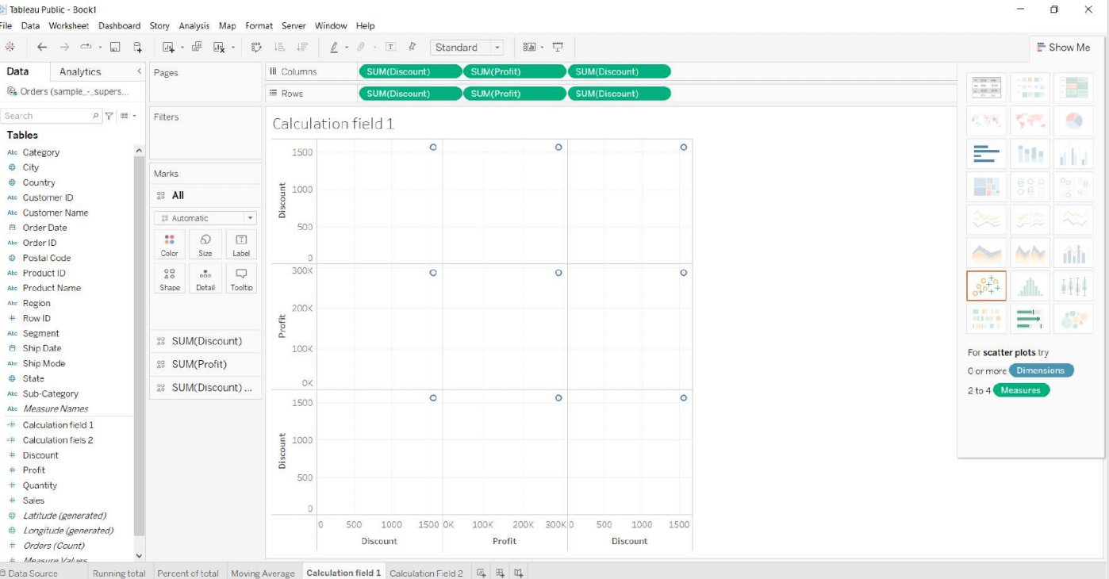

**Calculation Field-2:**

